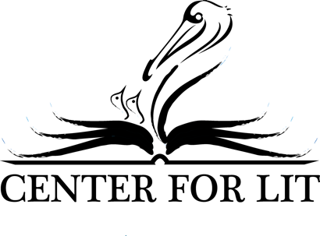

Ian Andrews: Lecture Titles

Would you like Ian to speak on something that does not appear on this list? Call (509) 738-2837 or email i.andrews@centerforlit.com to make arrangements.

3 Keys to Success in College

Ian Andrews, K-12 homeschooler and Hillsdale College graduate, reflects on his own literary education, offering three key principles for continued success in higher education, while recommending a book that every high school student should read before graduating.

Why Your Kids Love Fantasy Literature – and What To Do About It
All children play make-believe; and while they are little, allowing their imaginations to fuel their play is a harmless joy. But what if they soon yearn for the worlds they find in their favorite novels: strange worlds, imaginary worlds, non-Christian worlds? What if they lose themselves in Fantasy? Ian Andrews summarizes a few well-known fantasy stories, and shares some simple literary tools that will help you start meaningful conversations about the joys and dangers of fantasy literature.
Story Time with CenterForLit
In a distilled presentation of the revolutionary Teaching the Classics discussion method, Ian Andrews demonstrates the simple tools for literary analysis by reading aloud from a classic picture story book and inviting listeners of all ages to participate in discussing its themes. No matter their length or difficulty, all stories share common elements, tools in the arsenal of the author to communicate timeless truths. Join Ian as he offers a key to unlock those truths in any story!

Failure and Fatherhood – The Story of a Homeschool Family Feud
Adam and Ian Andrews recount the difficulties of their shared scholastic journey. Sons and Fathers alike will find something – and someone – to relate to in the testimony of these two homeschool veterans. What do our children need most from their fathers? How can we be sure to give it to them? Most importantly, how do we fix things when we do it wrong? Come hear about the hope that waits for us all on the other side of failure. You will find balm for your wounds, peace for your mind, and rest for your soul – and all in a most unlikely place.

Symbolism: Mastering Literature’s Most Powerful Device
No matter the author or genre, every work of literature is built in part on symbols. Identifying them, however, can be frustrating and difficult. Often it seems that an author’s symbols obscure his themes instead of making them clear. In a riveting presentation of one of the earliest English Poems, Ian Andrews explains this powerful device and shows how it can help you unlock the meaning of even the most difficult classics. All you need is the right series of simple questions.

